- 1. Be Your Own Favorite Teacher

R R R
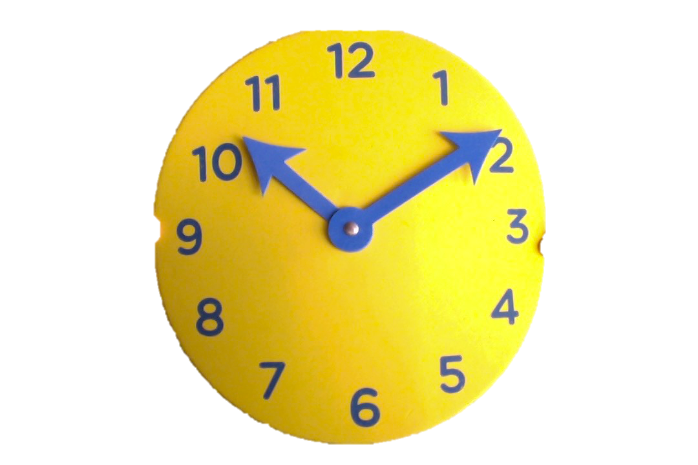
Dear Teacher,
You deserve to claim satisfaction and joy from your ongoing teaching efforts. You can reduce the time spent on classroom discipline AND spend more time with students learning.

It’s time to let your effectiveness shine… Make it common to have peace and productivity in your classroom...Be your own favorite teacher.

Let your principal know which of these TMI sessions you would like or sign up for yourself.

Each segment starts with about
Ten Minutes of Information
As Audio, pdf, powerpoint, or video
Prompts discussion, planning, or commitment

TeacherTMI.com
510-717-3505 msg./text
- Reflection on Practices
- Know your Professional Power
- Build Your Professional Image
- Positivity Mindset
- Ready, Set, Go for Back-to-School

- 2. Getting Ready to Get Ready
- Applied Ed. Psych Theories
- Politically Responsive Teaching
- Writing a Classroom Syllabus
- 50-minute Lesson Strategy
- Long and Short Range Planning
- Students who Resist or Rebel

- 3. Rules for Making Rules
- Classroom Set-up
- Establishing Rules
- Building Classroom Culture
- Back-to-School Night
- Observations and Evaluations

- 4. English and Reading K-12
- Reading in Content Areas
- Modalities in Reading
- Spanish Readers
- Encouraging the unwilling Reader
- Stepping Stones of Reading Recovery
- Buddy Book Literature
- Vocabulary, Spelling, Penmanship

- 5. Math K-8
- Indoor and Outdoor Math
- Integrated Curriculum
- Odd Facts
- Quick Drills
- Fewer Take-home Correcting

- 6. Special Ed. Techniques
- Organizing My Data
- Data Collection
- Learning Stations
- Managing Support Personnel
- IEP Strategies

- 7. Extra for Experts
- Parent Conferences
- Science Everyday
- History or Social Studies?
- ELD
- Observations and evaluations
- Reduce Bullying
- Inclusion

- 8. For Leaders
- 15-Minute Purposeful Conference
- Communication at its Best
- Guiding the Tough Conversation
- Eliminating Negativity
- Leading a Staff of Varied Ages,

